Wang et al., Alarming antibody evasion properties of rising SARS-CoV-2 BQ and XBB subvariants

Cell (2023),

https://doi.org/10.1016/j.cell.2022.12.018

Article

Alarming antibody evasion properties of rising SARSCoV-2 BQ and XBB subvariants

SARSCoV-2 BQ和XBB亚变异株增强的抗体逃逸特性

发布时间：2022年12月13日

**简单扼要**

----------------------------------------------------------------------------------------------------------------------------------------------------------------------------------

Recent BQ and XBB subvariants of SARS-CoV-2 demonstrate dramatically increased ability to evade neutralizing antibodies, even those from people who received the bivalent mRNA booster or who are immunized and had previous breakthrough Omicron infection.

SARS-CoV-2最近的BQ和XBB亚变体显示出显著增强了逃避中和抗体的能力，即使是那些接受二价mRNA增强剂或已免疫且之前曾出现奥密克戎突破性感染的人。

Additionally, both BQ and XBB are completely resistant to bebtelovimab, meaning there are now no clinically authorized therapeutic antibodies effective against these circulating variants.

此外，BQ和XBB对bebtelovimab都完全耐药，这意味着现在没有临床授权的治疗抗体对这些循环变体有效。

**摘要**

----------------------------------------------------------------------------------------------------------------------------------------------------------------------------------

SARS-CoV-2奥密克戎的BQ和XBB亚变体现在正在迅速扩大，这可能是由于其额外的刺突蛋白突变导致的抗体逃避特性改变。在这里，我们报告了来自接种者和感染者的血清对BQ.1、BQ.1.1、XBB和XBB.1的中和显著受损，

包括来自用WA1/BA.5二价mRNA疫苗增强的个体的血清。BQ和XBB亚变体的滴度分别降低了13至81倍和66至155倍，远远超出了迄今为止的观察结果。能够中和原始奥密克戎变异株的单克隆抗体在很大程度上对这些新的亚变异株不起作用，并确定了负责的个体刺突蛋白突变。发现这些亚变体与它们的前体具有相似的ACE2结合亲和力。总之，我们的研究结果表明，BQ和XBB亚变异体对当前的新冠肺炎疫苗构成严重威胁，使所有经授权的抗体失效，并可能因其规避抗体的优势而在人群中占据优势。

**引言**

----------------------------------------------------------------------------------------------------------------------------------------------------------------------------------

由严重急性呼吸综合征冠状病毒2（SARS-CoV-2）引起的新冠肺炎-2019（COVID-19）大流行，由于Omicron变异体及其后代亚变异体的出现而继续肆虐。(refs.1-10)尽管BA.5亚变异物目前在全球占主导地位（Figure 1A），各种各样的奥密克戎亚型已经出现，并正在所谓的“variant soup”中竞争。(refs.11)很明显，四种新的亚型正在迅速占领BA.5，这引发了未来几个月又一波感染的担忧。BQ.1和BQ.1.1于7月初在尼日利亚首次发现，随后在欧洲和北美急剧扩大，目前分别占法国、英国和美国病例的67%、35%和47%（Figure 1A）。XBB和XBB.1于8月中旬首次在印度被发现，并迅速在印度、新加坡和亚洲其他地区占据主导地位（Figure 1A）。BQ.1和BQ.1.1从BA.5进化而来，而XBB和XBB.1是由两个BA.2谱系BJ.1和BA.2.75之间的重组产生的（Figure 1B）。这两个亚系正在继续进化和多样化，棘突突变的复杂性不断增加。然而，除了BA.5中发现的突变外，主要BQ.1亚变体的刺突蛋白还含有K444T和N460K突变，BQ.1.1具有额外的R346T突变（Figure 1C和S1）。值得注意的是，除了BA.2中发现的突变外，主要XBB亚变体的尖峰有14个突变，包括N末端结构域（NTD）中的5个和受体结合结构域（RBD）中9个，而XBB.1有一个额外的G252V突变（Figure 1C和S1）。这些亚变异体的迅速增加及其广泛的尖峰突变使人想起去年出现的第一个Omicron变异体，因此人们担心它们可能会进一步损害当前新冠肺炎疫苗和单克隆抗体（mAb）疗法的疗效。我们现在报告的结果表明，令人遗憾的是，这种担忧是合理的，特别是对于XBB和XBB.1子变体。

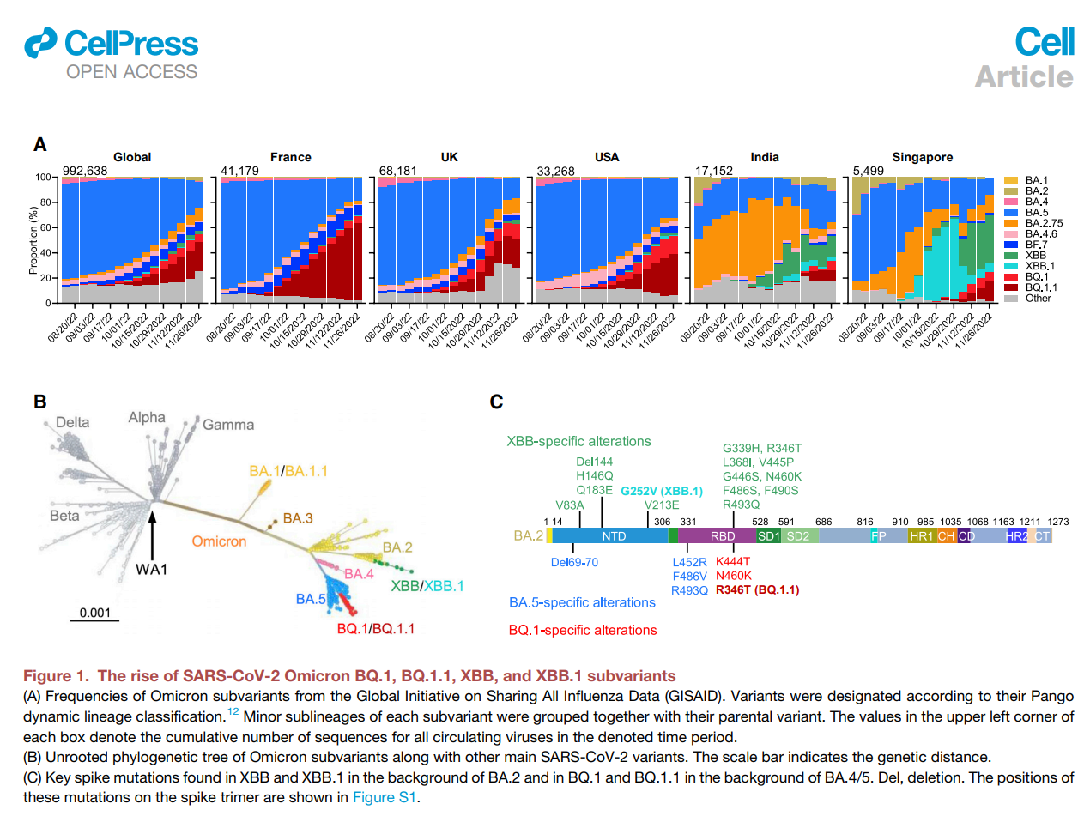

Figure 1

SARS-CoV-2奥密克戎BQ.1、BQ.1.1、XBB和XBB.1亚变异株的增加

（A） 来自全球流感数据共享倡议（GISAID）的奥密克戎亚变体的频率。根据其Pango动态谱系分类来指定变体。12每个亚变体的次要亚系与其亲本变体一起分组。每个框左上角的值表示指定时间段内所有循环病毒的累积序列数。

（B） 奥密克戎亚变异株以及其他主要SARS-CoV-2变异株的未生根系统发育树。比例尺表示遗传距离。

（C） BA.2背景下的XBB和XBB.1以及BA.4/5背景下的BQ.1和BQ.1.1中发现关键尖峰突变。Del，删除。这些突变在尖峰三聚体上的位置如Figure S1所示。

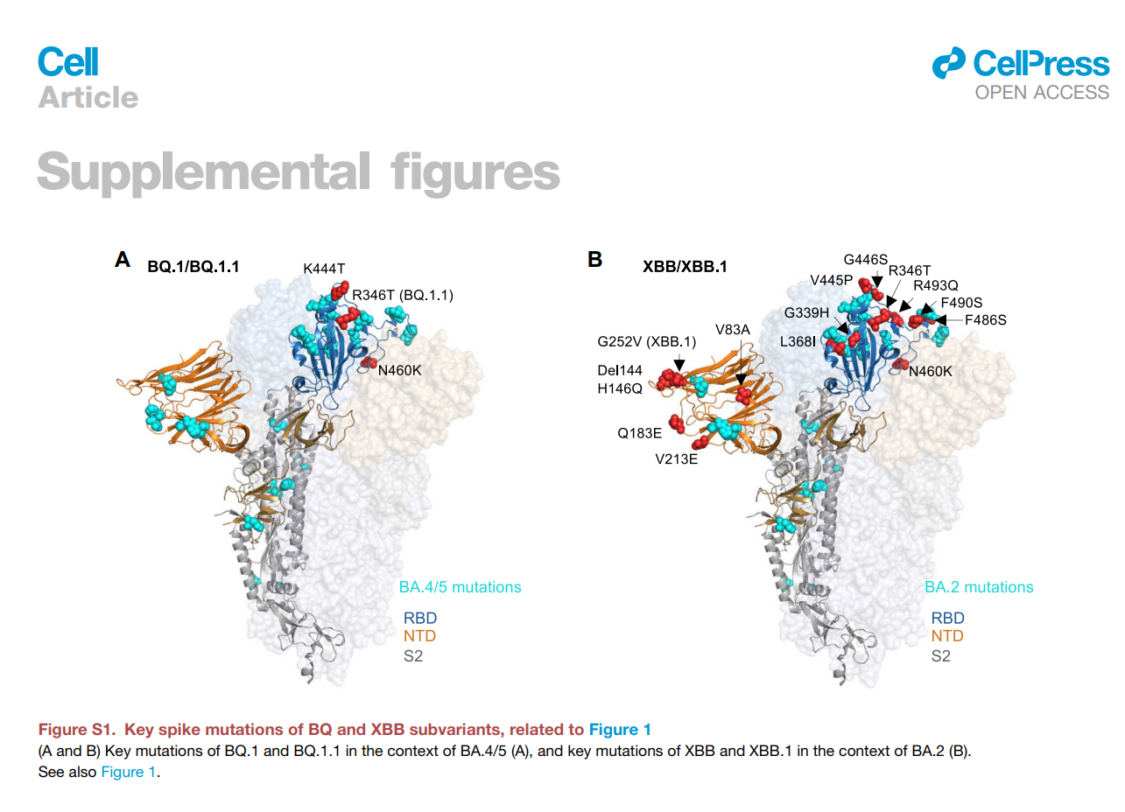

Figure S1

BQ和XBB亚变体的关键突变，与Figure 1（A和B）相关。在BA.4/5（A）基础上BQ.1和BQ.1.1的关键突变，以及在BA.2（B）基础上XBB和XBB.1的关键突变。

另请参见Figure 1.

INTRODUCTION

----------------------------------------------------------------------------------------------------------------------------------------------------------------------------------

The coronavirus disease 2019 (COVID-19) pandemic, caused by severe acute respiratory syndrome coronavirus 2 (SARS-CoV-2), continues to rage due to emergence of the Omicron variant and its descendant subvariants.1–10 Although the BA.5 subvariant is globally dominant at this time (Figure 1A), a diverse array of Omicron sublineages have arisen and are competing in the so-called ‘‘variant soup’’.11 It has become apparent that four new subvariants are rapidly gaining ground on BA.5, raising the specter of yet another wave of infections in the coming months. BQ.1 and BQ.1.1 were first identified in Nigeria in early July and then expanded dramatically in Europe and North America, now accounting for 67%, 35%, and 47% of cases in France, the United Kingdom, and the United States, respectively (Figure 1A). XBB and XBB.1 were first identified in India in mid-August and quickly became predominant in India, ingapore, and other regions in Asia (Figure 1A). BQ.1 and BQ.1.1 evolved from BA.5, whereas XBB and XBB.1 resulted from a recombination between two BA.2 lineages, BJ.1 and BA.2.75 (Figure 1B). These two sublineages are continuing to evolve and diversify, with an ever-increasing complexity of spike mutations. However, the spike protein of the predominant BQ.1 subvariant harbors the K444T and N460K mutations in addition to those found in BA.5, with BQ.1.1 having an additional R346T mutation (Figures 1C and S1). Strikingly, the spike of the predominant XBB subvariant has 14 mutations in addition to those found in BA.2, including 5 in the N-terminal domain (NTD) and 9 in the receptor-binding domain (RBD), whereas XBB.1 has an additional G252V mutation (Figures 1C and S1). The rapid rise of these subvariants and their extensive array of spike mutations are reminiscent of the appearance of the first Omicron variant last year, thus raising concerns that they may further compromise the efficacy of current COVID-19 vaccines and monoclonal antibody (mAb) therapeutics. We now report findings that indicate that such concerns are, sadly, justified, especially so for the XBB and XBB.1 subvariants.

参考资料：

新冠XBB毒株最新研究结果全面解析

https://www.bilibili.com/video/BV1bY41117cx/?spm_id_from=333.1007.tianma.1-1-1.click&vd_source=0ed4c08cbb2ed3d76e43c4c48d9159c7

研究表明：BQ和XBB逃逸能力是目前已知最强！国内已有49例！

https://zhuanlan.zhihu.com/p/592923620

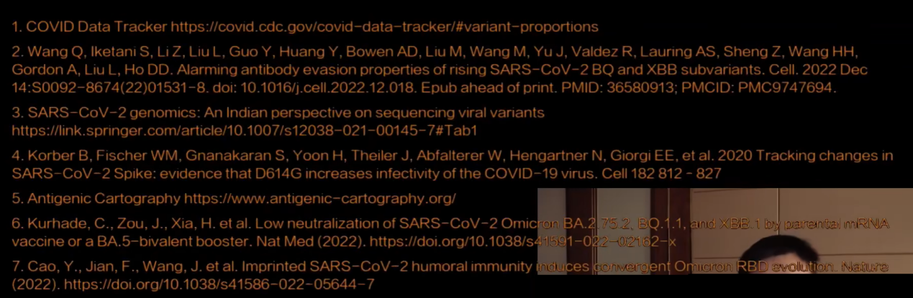

参考资料：

[Centers for Disease Control and Prevention](https://www.cdc.gov/" \t "https://www.google.com.hk/_blank)

https://www.cdc.gov/

Covid Data Tracker

https://covid.cdc.gov/covid-data-tracker/#variant-proportions

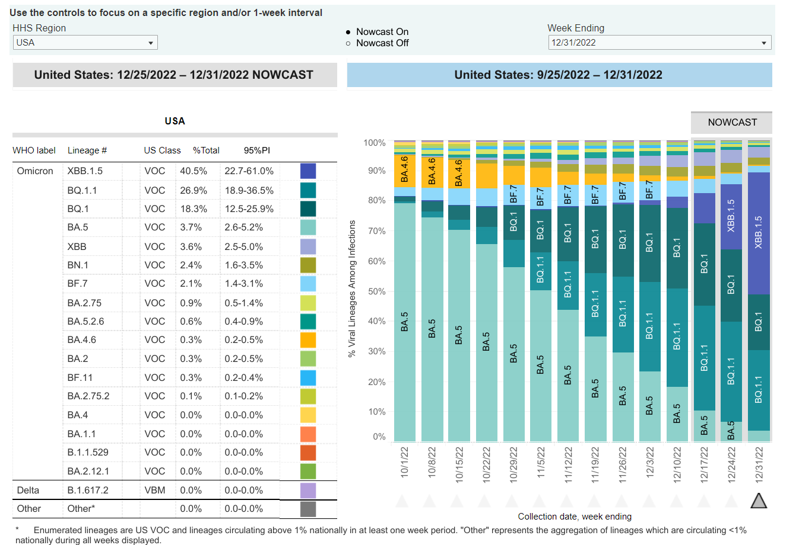

参考资料：

# 贝特洛维单抗

Bebtelovimab是一种[单克隆抗体](https://en.wikipedia.org/wiki/Monoclonal_antibody" \o "单克隆抗体)，由[AbCelera](https://en.wikipedia.org/wiki/AbCellera" \o "AbCelera)和[Eli Lilly](https://en.wikipedia.org/wiki/Eli_Lilly_and_Company" \o "礼来公司)开发，用于治疗[COVID-19](https://en.wikipedia.org/wiki/COVID-19" \o "新冠肺炎)。

Bebtelovimab 于2022 年 2 月获得美国[食品和药物管理局](https://en.wikipedia.org/wiki/Food_and_Drug_Administration" \o "食品和药物管理局)(FDA)的[紧急使用授权(EUA)，](https://en.wikipedia.org/wiki/Emergency_use_authorization" \o "紧急使用授权)并于 2022 年 11 月撤销。

截至 2022 年 11 月，bebtelovimab 未获准在美国紧急使用，因为预计它不会中和 Omicron 亚变体 BQ.1 和 BQ.1.1。